**1. INTRODUCTION**

**1.1 Project Overview :**

These days, there are numerous types of diets that aim to improve the health, quality of life and longevity of people. New studies are made year by year about the importance of a healthy diet (e.g. considering aural health of the elderly, reducing the chance of heart failure and cognitive impairment, etc.).

One way to achieve this is by adopting one of the many existing diets. As the Internet gains dominance as the primary source of information in the daily life of people, it is naturally among the first places one would start looking for such information, although numerous online sources have been shown to lack accuracy considering dietary guidelines. There are existing initiatives that effectively use technology to educate people about nutrition science (e.g. studied the effectiveness of teaching about nutrition to information technology (IT) professionals through e-learning, studied the feasibility of a text message-based mobile nutrition wellness program, etc.)

However, using existing dietary guidelines typically involve a strictly planned out regime, which can be hard to get used to or even to follow through, due to the sudden nature of the change. A solution to this problem can be a slow but gradual change of diet, which has a bigger chance to be successful if the changes align with the personal taste of the user. Starting from the regular diet, it would be very beneficial if the user observed the current nutritional values of his or her diet, and make gradual changes through informed decisions accordingly.

Due to the ignorance of healthy food habits, obesity rates are increasing at an alarming speed, and this is reflective of the risks to people’s health. People need to control their daily calorie intake by eating healthier foods, which is the most basic method to avoid obesity. However, although food packaging comes with nutrition (and calorie) labels, it’s still not very convenient for people to refer to App-based nutrient dashboard systems which can analyze real-time images of a meal and analyze it for nutritional content which can be very handy and improves the dietary habits, and therefore, helps in maintaining a healthy lifestyle.

The Public Health Division within the Department of Health, Housing and Human Services promotes and protects the health of County residents through population-based programs and services. These include immunizations, prenatal care and family planning services provided in conjunction with the County’s Federally Qualified Health Clinics (FQHC). Other services include nutrition education and support through WIC, emergency planning and response, vital records, community engagement to identify and address health problems, communicable disease control and food safety measures.

The Nutrition Assistant assesses client eligibility for participation in the Women, Infants and Children (WIC) Supplemental Food Program and provides targeted and best practice nutrition information, education and counseling to clients.

The Nutrition Assistant differs from the professional Nutritionist which serves high risk clients, acts as a technical advisor, and provides advanced nutrition counseling and education programs throughout the County. It also differs from the Health Assistant which assists health care providers in providing general health care to clinic patients.

**1.2 Purpose :**

The aim of this project will include obtaining dietary information from patients, determining nutritional needs, and observing patients for signs of diet-related complications. To ensure success, nutrition assistants should possess experience in a similar role and the ability to obtain accurate dietary information. A top-notch nutrition assistant will be someone who can proactively help nutritionists to improve their well-being through excellent dietary support. Performing on going nutrition assessments, including the measurement of caloric intake and activity levels.

**2. LITERATURE SURVEY**

**2.1 Existing problem:**

**2.2 References:**

|  |  |  |  |  |
| --- | --- | --- | --- | --- |
| **TITLE AND AUTHOR(S)** | **YEAR** | **TECHNIQUE(S)** | **FINDINGS** | **PROS AND CONS** |
| Enhancing Cloud and healthy Food Nutrition Information Systems Practice-  Paul, PK and Aithal, PS and Bhuimali, A | 2017 | Cloud Computing, Mobile Computing | Food information systems are not yet widely used in the general mass market, thus there is a tonne of room for improvement. | P: There are many aspects that are still up for discussion and consideration in relation to manpower development. In order to construct complex food information systems, the cloud will pay attention to talent and human resource  development. |
| Mobile cloud based system recognizing nutrition and freshness of food image-  Kumbhar, Diptee and Patil, Sarita | 2017 | Cloud Computing, Image Segmentation | It has been suggested that mobile cloud computing (MCC) could serve as a paradigm for mobile health services to get beyond the interoperability problems caused by various information formats. In this, we suggest a framework for measuring food calories that is cloud-based and mobile. | P: Cost-effective Multiple Platform Support  C: Performance and Connectivity Issues |
| Predicting calorific value for mixed food using image processing-  Kohila, R and Meenakumari, R | 2017 | Cloud Computing, Image Segmentation | In order to assist patients and nutritionists, this research aims to anticipate and correct diet control for a variety of diseases by evaluating calorific value. The calorie content of the food can be determined from the image obtained by a mobile phone or tablet camera. | P: Enhanced safety decreased cost  C: Limited authority  Lacks Assistance |
| Use of artificial intelligence in precision nutrition and fitness-  de Moraes Lopes, Maria Helena Baena and Ferreira, Danton Diego and Ferreira, Ana Claudia Barbosa Honorio and da Silva, Giuliano Roberto and Caetano, Aletha Silva and Braz | 2020 | Artificial Intelligence, Nutritional surveillance | Artificial intelligence (AI) is one of the computational tools that has recently drawn increasing attention because it is able to learn and model linear and nonlinear relationships between variables by creating an input-output mapping that reveals and interprets hidden and extremely useful information for decision-making. | P:These  technologies acquire an enormous amount of data.  C:The usage of AI in the fields of fitness and nutrition is still limited. |

**2.3 Problem Statement:**

Due to the ignorance of healthy food habits, obesity rates are increasing at an alarming speed, and this is reflective of the risks to people’s health. People need to control their daily calorie intake by eating healthier foods, which is the most basic method to avoid obesity. However, although food packaging comes with nutrition (and calorie) labels, it’s still not very convenient for people to refer to App-based nutrient dashboard systems which can analyze real-time images of a meal and analyze it for nutritional content which can be very handy and improves the dietary habits, and therefore, helps in maintaining a healthy lifestyle. The main objective of this project is to building a web App that automatically estimates food attributes such as ingredients and nutritional value by classifying the input image of food.

**3. IDEATION & PROPOSED SOLUTION:**

**3.1 Empathy Map Canvas: .**

This project's objectives include gathering dietary data from patients, figuring out their nutritional requirements, and keeping an eye out for symptoms of difficulties caused by food. Nutrition aides must have previous expertise in a related position and the capacity to gather precise nutritional data if they are to be successful. Someone who can proactively assist nutritionists in enhancing their well-being through superior nutritional support will make a top-notch nutrition assistant. doing ongoing nutritional assessments, which include calculating calorie intake and activity levels.

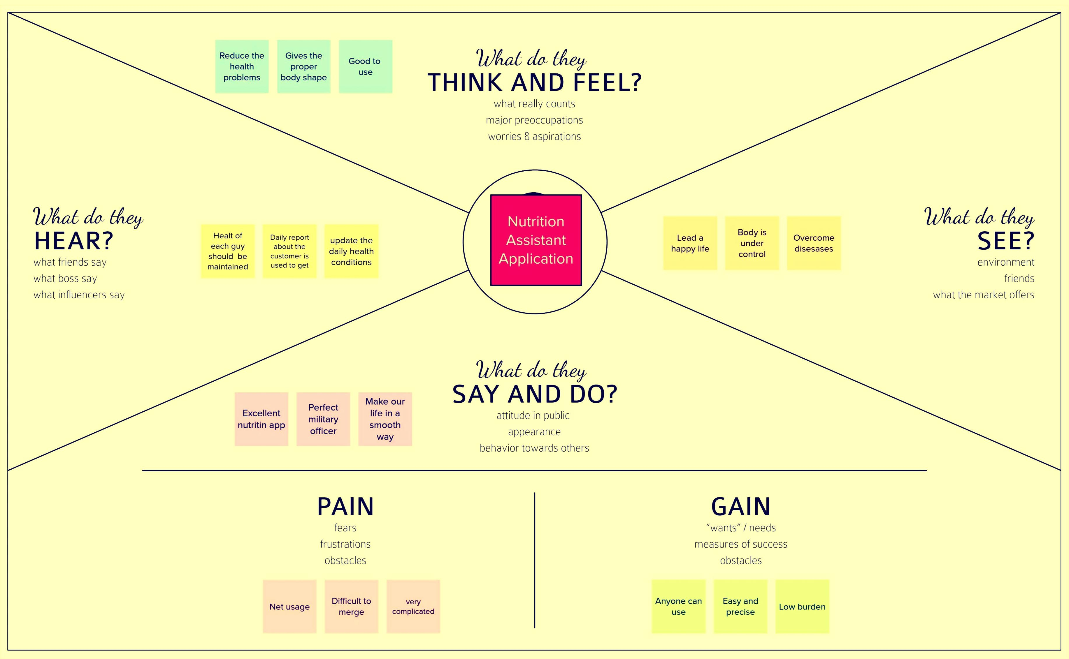

**3.2 Ideation & Brainstorming:**

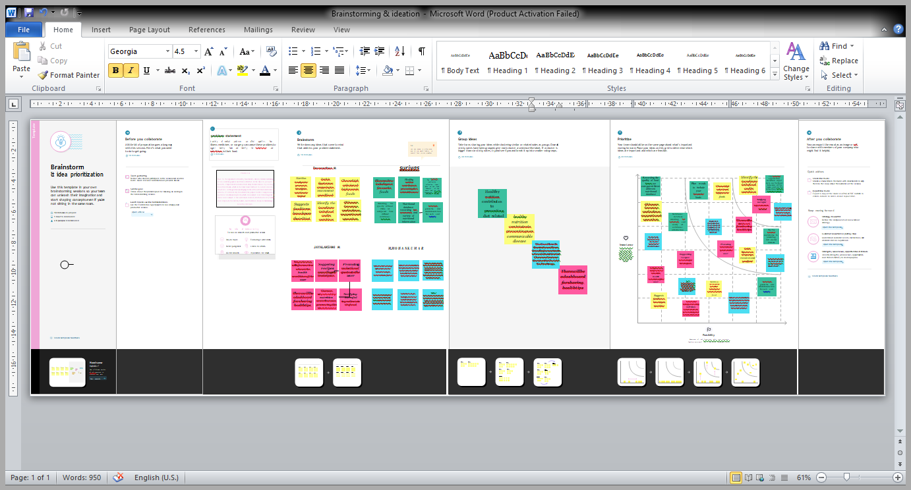

**3.3 Proposed Solution :**

|  |  |  |
| --- | --- | --- |
| **S.NO** | **Parameter** | **Description** |
| 1 | Problem Statement (Problem to be solved) | Now a days peoples are not eating healthy foods with respect to their health condition. If it happens continuously means, it will lead to obesity and any other health problems.  To avoid that the system will detect and recognize the food and evaluating the nutrient values present in the food. |
| 2 | Idea / Solution description | To store the food and details of the nutrients present in it.  Then scan the real time food and retrieve the corresponding food’s nutrient values. |
| 3 | Novelty / Uniqueness | Clustering the peoples based on their BMI value. |
| 4 | Social Impact / Customer Satisfaction | The application which gives awareness among the people about the obesity and various health problems. |
| 5 | Business Model (Revenue Model) | In market, this application gives a benefit across the people by health wise and economical wise. |
| 6 | Scalability of the Solution | The application which creates an impact among the healthy lifestyle. |

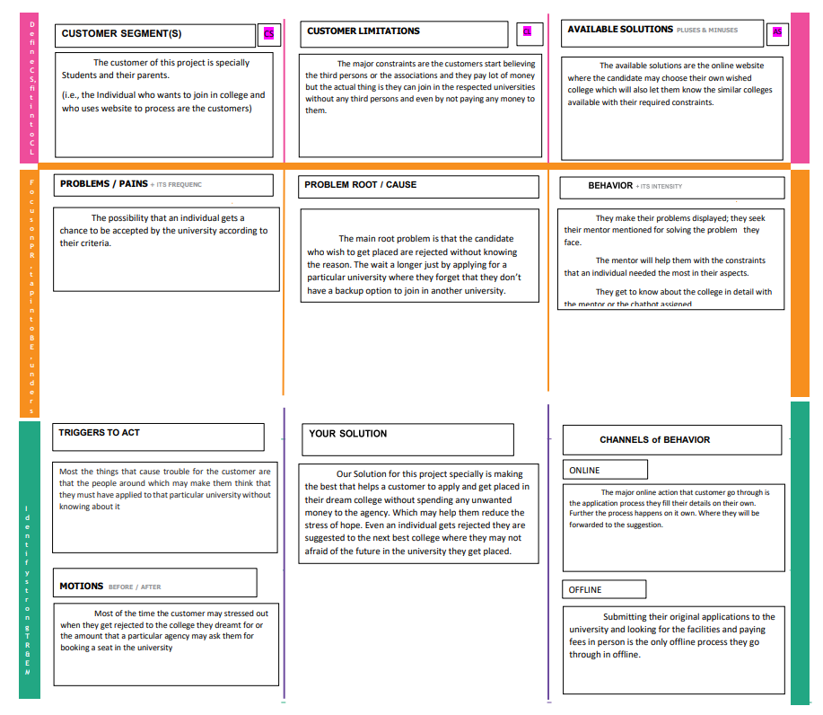**3.4 Problem Solution fit :**

**4. REQUIREMENT ANALYSIS**

**4.1 Functional requirement :**

Following are the functional requirements of the proposed solution.

|  |  |  |
| --- | --- | --- |
| **S.NO** | **Functional Requirement (EPIC)** | **Sub Requirement (Story / Sub-Task)** |
| 1 | User Registration | Registration through email |
| 2 | User Confirmation | Confirmation via email |
| 3 | Data Collection | Collection of all required input data |
| 4 | Data Analysis | Process the given inputs using CNN and Nutrition API |
| 5 | Data processing | Evaluate the data and store it in database and integrate in cloud containers |
| 6 | Provide output to user | Display the result to the user |

**4.2 Non-Functional requirements:**

Following are the non-functional requirements of the proposed solution.

|  |  |  |
| --- | --- | --- |
| **S.NO** | **Non-Functional requirements** | **Description** |
| 1 | Usability | Only registered user can use the application |
| 2 | Security | Authentication of user is done for security purpose |
| 3 | Operational | The user gets the standard nutritional value of the given food |
| 4 | Performance | User satisfaction is ensured by getting their feed back |
| 5 | Availability | This application is can be used when user is in online |
| 6 | Scalability | This application can be used in all OS and it can handle up to quite large data. |

**5. PROJECT DESIGN**

**5.1 Data Flow Diagrams :**

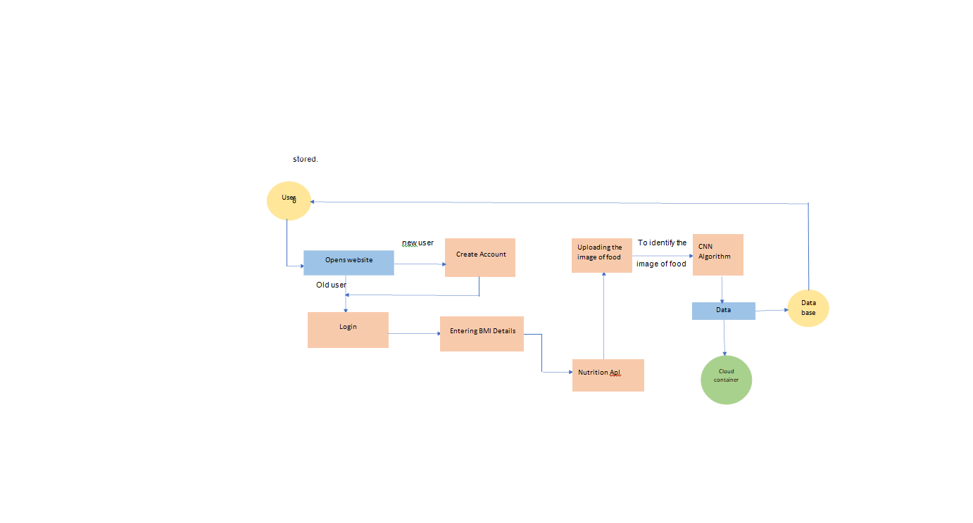**5.2 Solution & Technical Architecture :**

**Solution Architecture :**

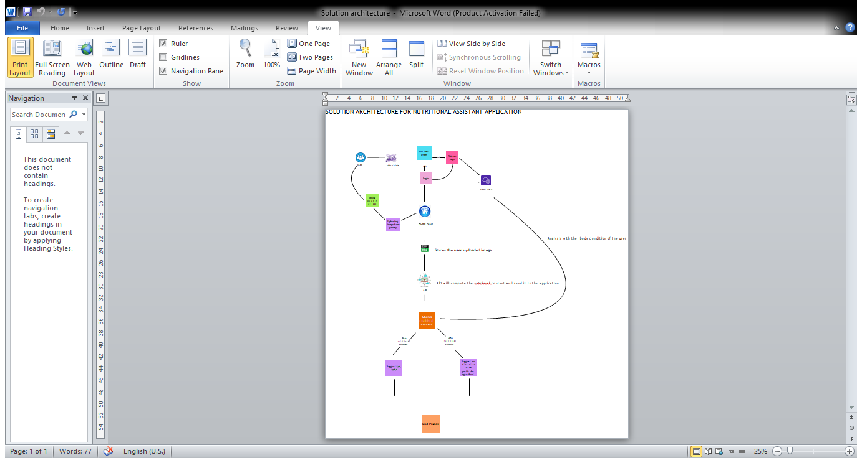

**Technical Architecture :**

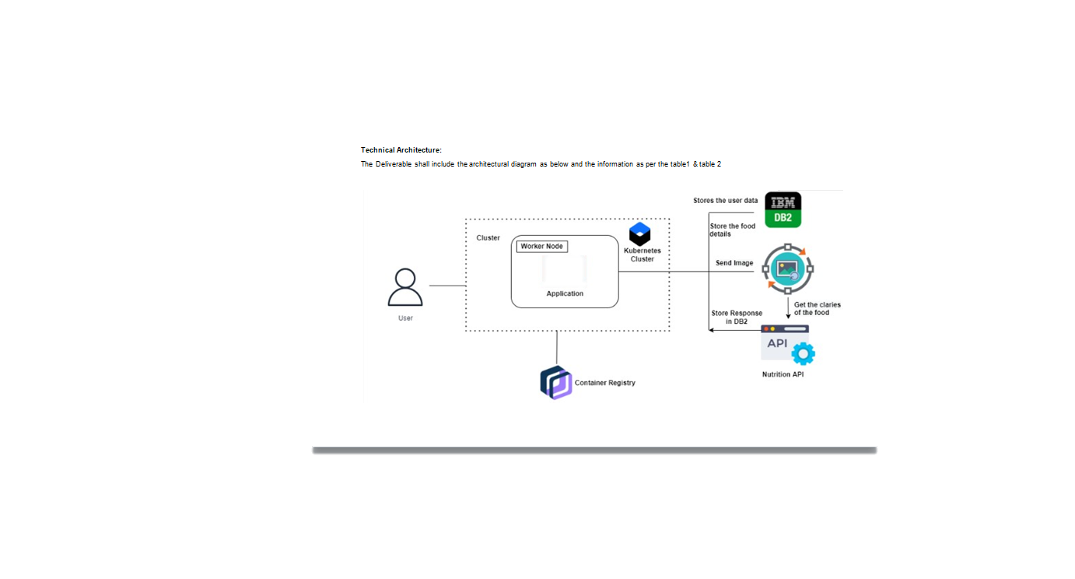**5.3 User Stories :**

|  |  |  |  |  |  |  |
| --- | --- | --- | --- | --- | --- | --- |
| **User Type** | **Functional**  **Requirement**  **(Epic)** | **User**  **Story**  **Number** | **User Story / Task** | **Acceptance criteria** | **Priority** | **Release** |
| User(All common people) | User Registration | USN - 1 | As a user, I can register for the application by entering my name,email, password. | I can access my dashboard. | High | Sprint-1 |
|  | Login | USN – 2 | As a user, I can login to the application using my given credentials. | I can access my dashboard. | Medium | Sprint-1 |
|  | BMI Calculation | USN – 3 | As a user, I enter my height and weight details. | I can get to know about my BMI | Medium | Sprint-2 |
|  | Uploading the Image | USN – 4 | As a user, I will upload the image of food that I want to eat. | I can upload the image to decide whether to eat or not. | Medium | Sprint-2 |
|  | Providing output to user | USN – 5 | As a user, I will get to know the results of  the inputs I’ve given. | I will get to know if I can eat the food or not. | Low | Sprint-3 |
| Administrator | Data Analysis | USN – 6 | As an admin, I will develop algorithms and modules to process the data. | I can store the result in database | Medium | Sprint-3 |
|  | Integrating with Cloud | USN – 7 | As a admin, I integrate the results in cloud containers. | I can deploy the data in cloud. | Medium | Sprint-3 |

**PROJECT PLANNING & SCHEDULING**

**6.1 Sprint Planning & Estimation :**

|  |  |  |  |  |  |  |
| --- | --- | --- | --- | --- | --- | --- |
| **Sprints** | **Functional Requirement (Epic)** | **User Story Number** | **User Story / Task** | **Story Points** | **Priority** | **Team Members** |
| Sprint – 1 | Home page | USN-1 | As a user, I can register for the application by entering my email, password, and confirming my password. | 3 | Medium | 4 |
| Sprint – 1 | Notify | USN-2 | As a user, I will receive confirmation email once I have registered for the application. | 3 | Medium | 4 |
| Sprint – 1 | Login page | USN-3 | As a user, I can log into the application by entering email & password.. | 4 | Medium | 4 |
| Sprint – 1 | Registration page | USN-4 | A new user have to register and login to access the web app | 4 | Medium | 4 |
| Sprint – 1 | Database management & connectivity | USN-5 | As a user, I can fill the Details. | 3 | Medium | 4 |
| Sprint – 1 | API (Clarifai) | USN-6 | The connection b/w the web app and the clarifai ap | 3 | Medium | 4 |
| Sprint - 2 | Chatbot | USN-7 | The user can also directly talk to the webpage and ask question using chatbot | 5 | High | 4 |
| Sprint - 2 | Shown the nutrition Recipe for scanned food | USN-8 | As a user, I can scan the food an get the nutrition details and recipe for related scanned | 5 | High | 4 |
| Sprint - 2 | Final Delivery | USN-9 | Integrate the application to Cloud using Docker and Kubernetes. Submit the report of the final application | 5 | High | 4 |

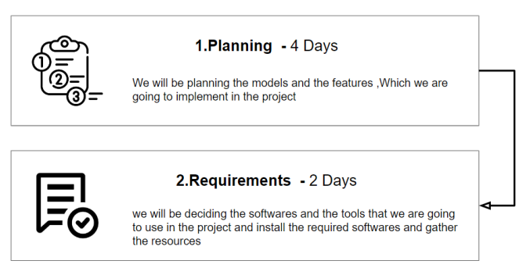**Milestone & Activity List :**

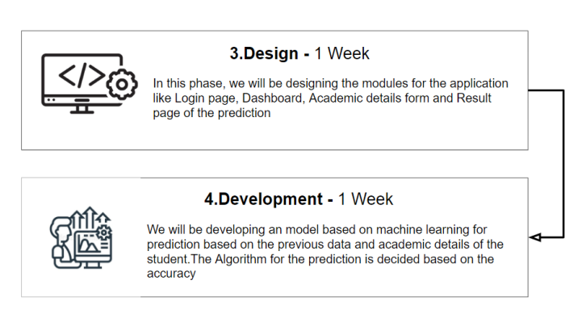**6.2 Sprint Delivery Schedule :**

|  |  |  |  |  |  |  |
| --- | --- | --- | --- | --- | --- | --- |
| **Sprint** | **Total Story Points** | **Duration** | **Sprint Start Date** | **Sprint End Date(Planned)** | **Story Points Completed (as on Planned End Date)** | **Sprint Release Date(Actual)** |
| Sprint-1 | 20 | 6 Days | 24 Oct 2022 | 29 Oct 2022 | 20 | 29 Oct 2022 |
| Sprint-2 | 20 | 6 Days | 31 Oct 2022 | 05 Nov 2022 | 20 | 05 Nov 2022 |
| Sprint-3 | 20 | 6 Days | 07 Nov 2022 | 12 Nov 2022 | 20 | 12 Nov 2022 |
| Sprint-4 | 20 | 6 Days | 14 Nov 2022 | 19 Nov 2022 | 20 | 19 Nov 2022 |

**Deliverables Plan and Schedules :**

|  |  |  |  |
| --- | --- | --- | --- |
| **S. No** | **Sprint** | **Deliverables** | **Date of Delivery** |
| 1 | Sprint-1 | Data Pre processing and data visualization module | 29 Oct 2022 |
| 2 | Sprint-2 | Machine Learning Modelling and Evaluation Module | 05 Nov 2022 |
| 3 | Sprint-3 | Web Application and Testing Module | 12 Nov 2022 |
| 4 | Sprint-4 | IBM Cloud Deployment Module | 19 Nov 2022 |

**6.3 Reports from JIRA :**

**All Sprints**

## ****Backlogs****

## ****Burnup Report****

**Cumulative Flow Diagram**

**Road Map**

**Sprint Burndown Chart 01**

**Sprint Burndown Chart 02**

**Sprint Burndown Chart 03**

**Velocity Report**

**7. CODING & SOLUTIONING (Explain the features added in the project along with code)**

**7.1 Feature 1 :**

**7.2 Feature 2 :**

**7.3 Database Schema : (if Applicable)**